**Wei Liang** **SP17**

**CST 2309-E286**

**Lab#11**

**Prof. Sancar Avcioglu March 21, 2017**

**Lab#11**

**Question1:**

**Mouse over:**

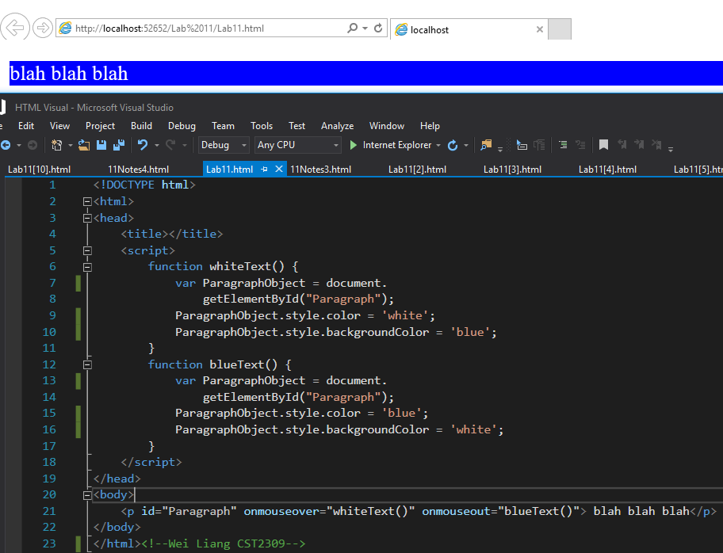

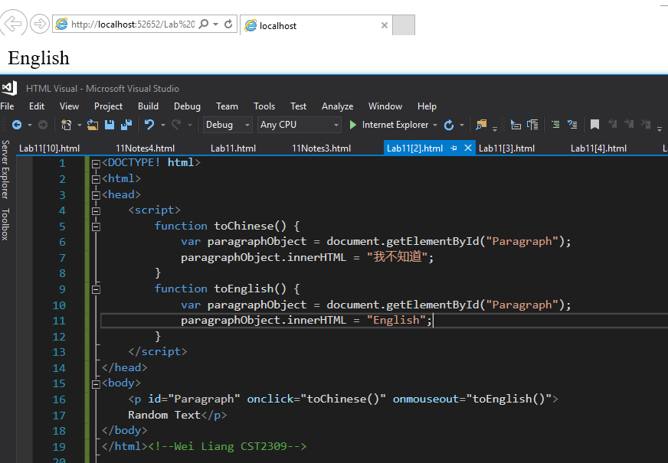

**Question2:**

**Mouse clicked**

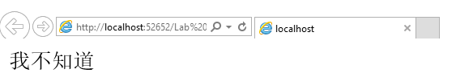

**Mouse out**

**Question3:**

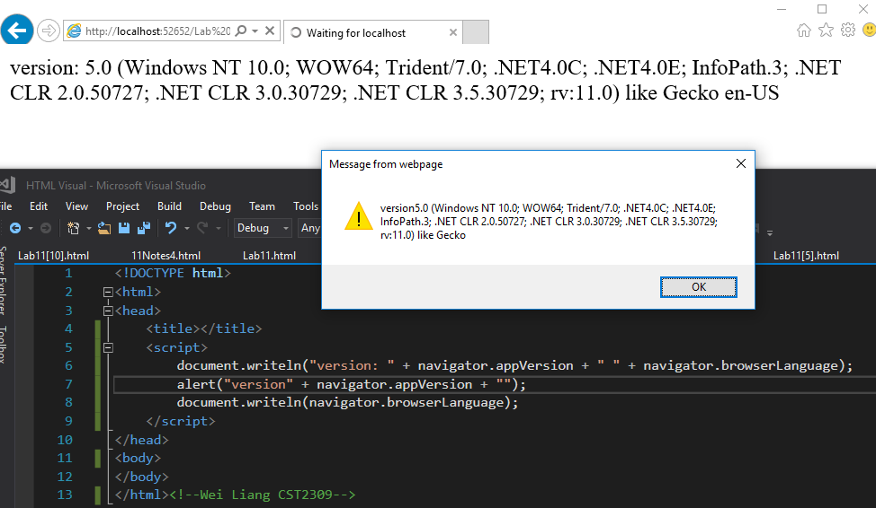

**Question4:**

**Web visited: Google & Yahoo**

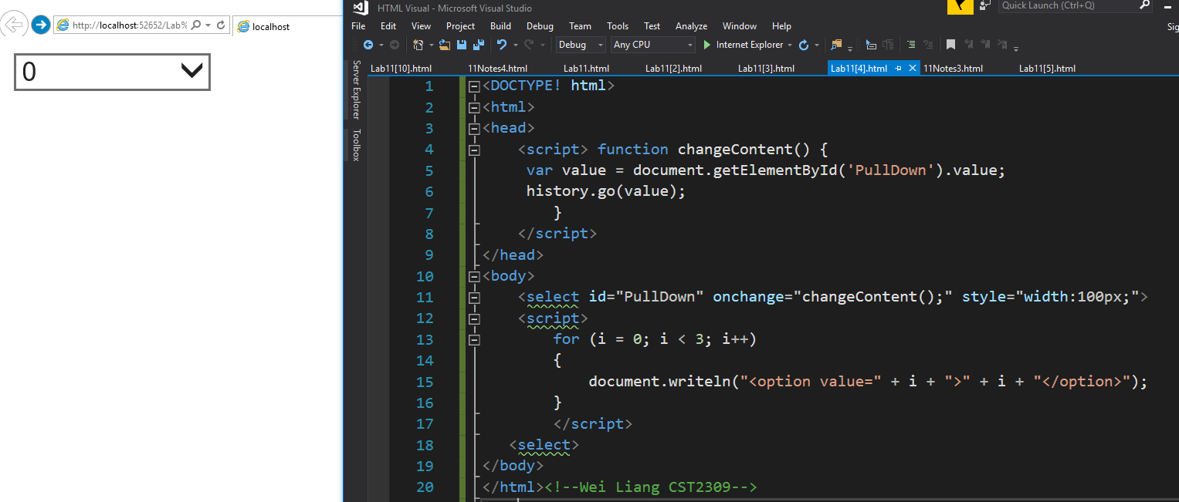

**Question5:**

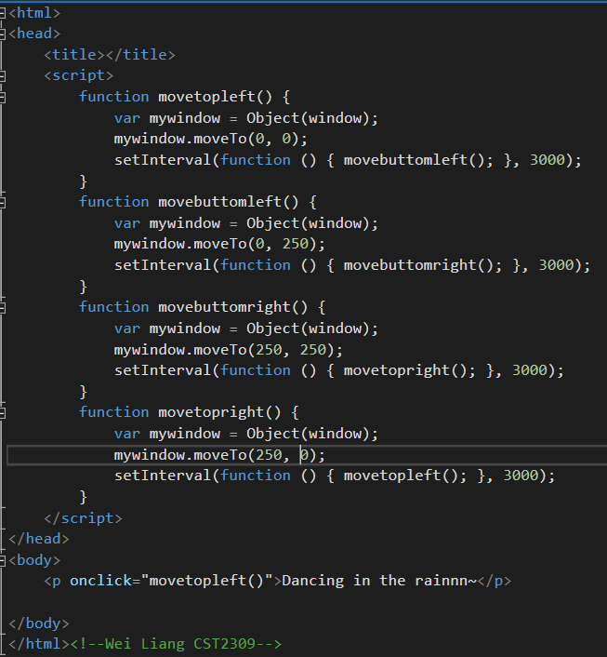

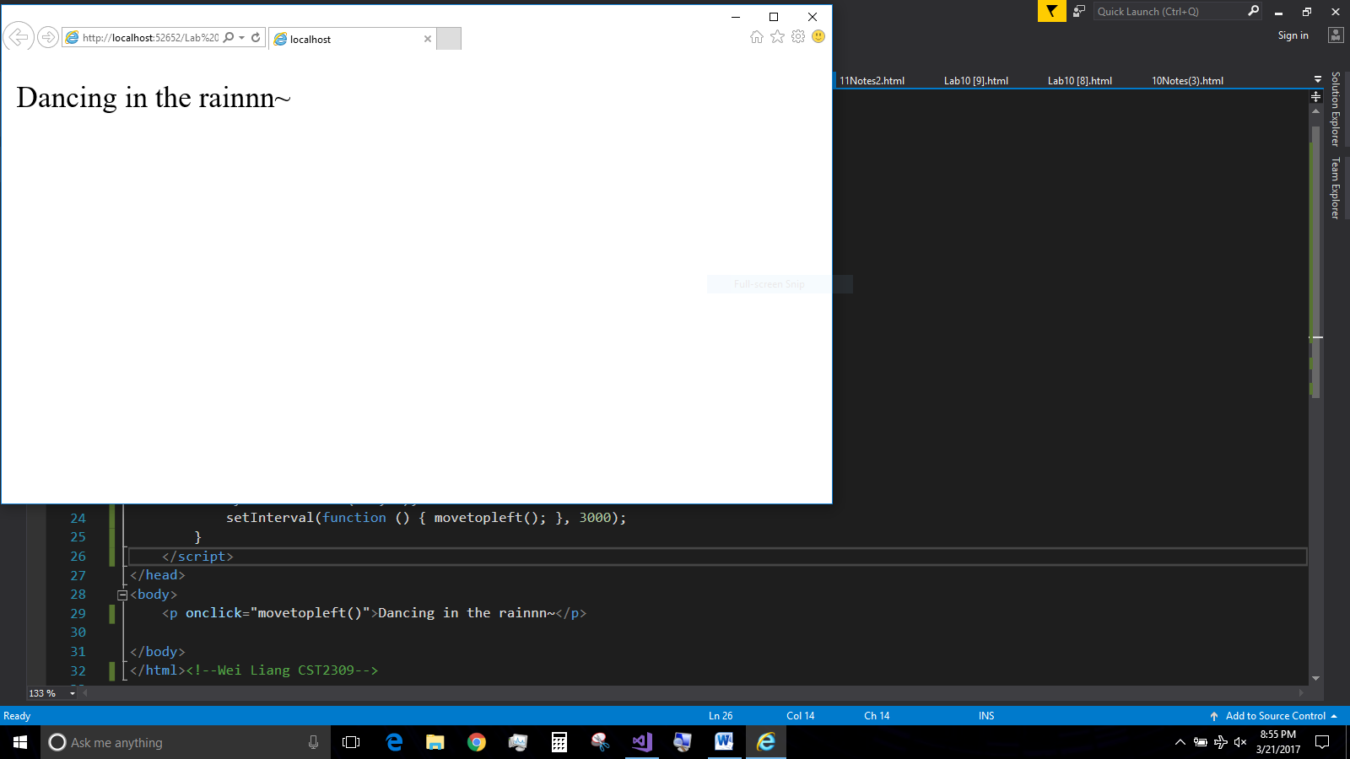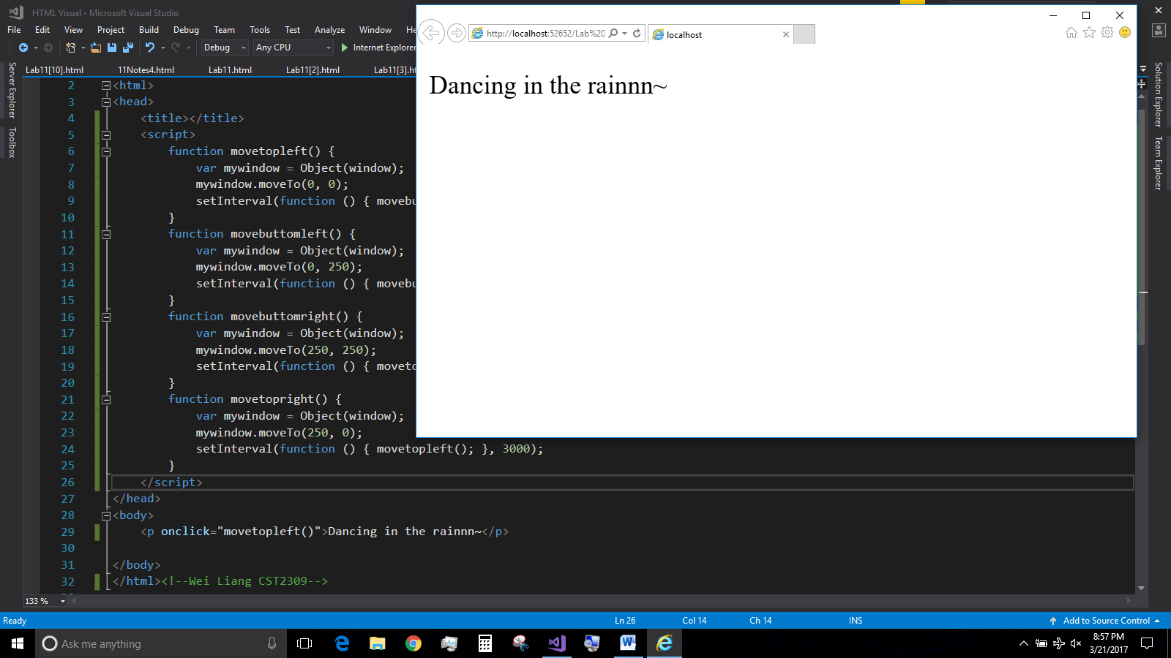

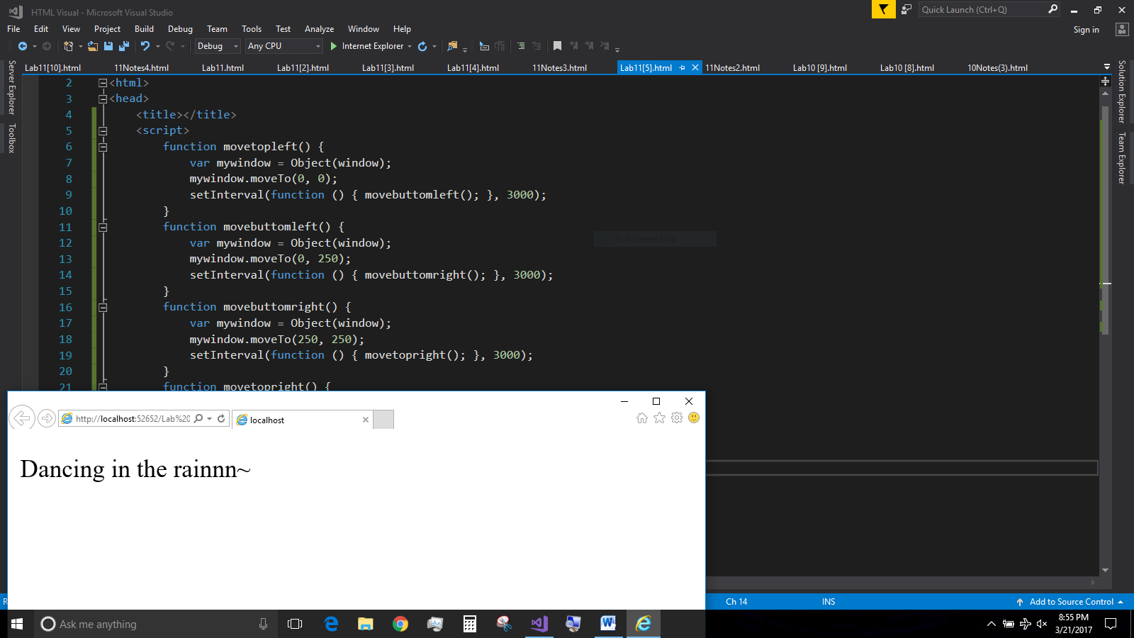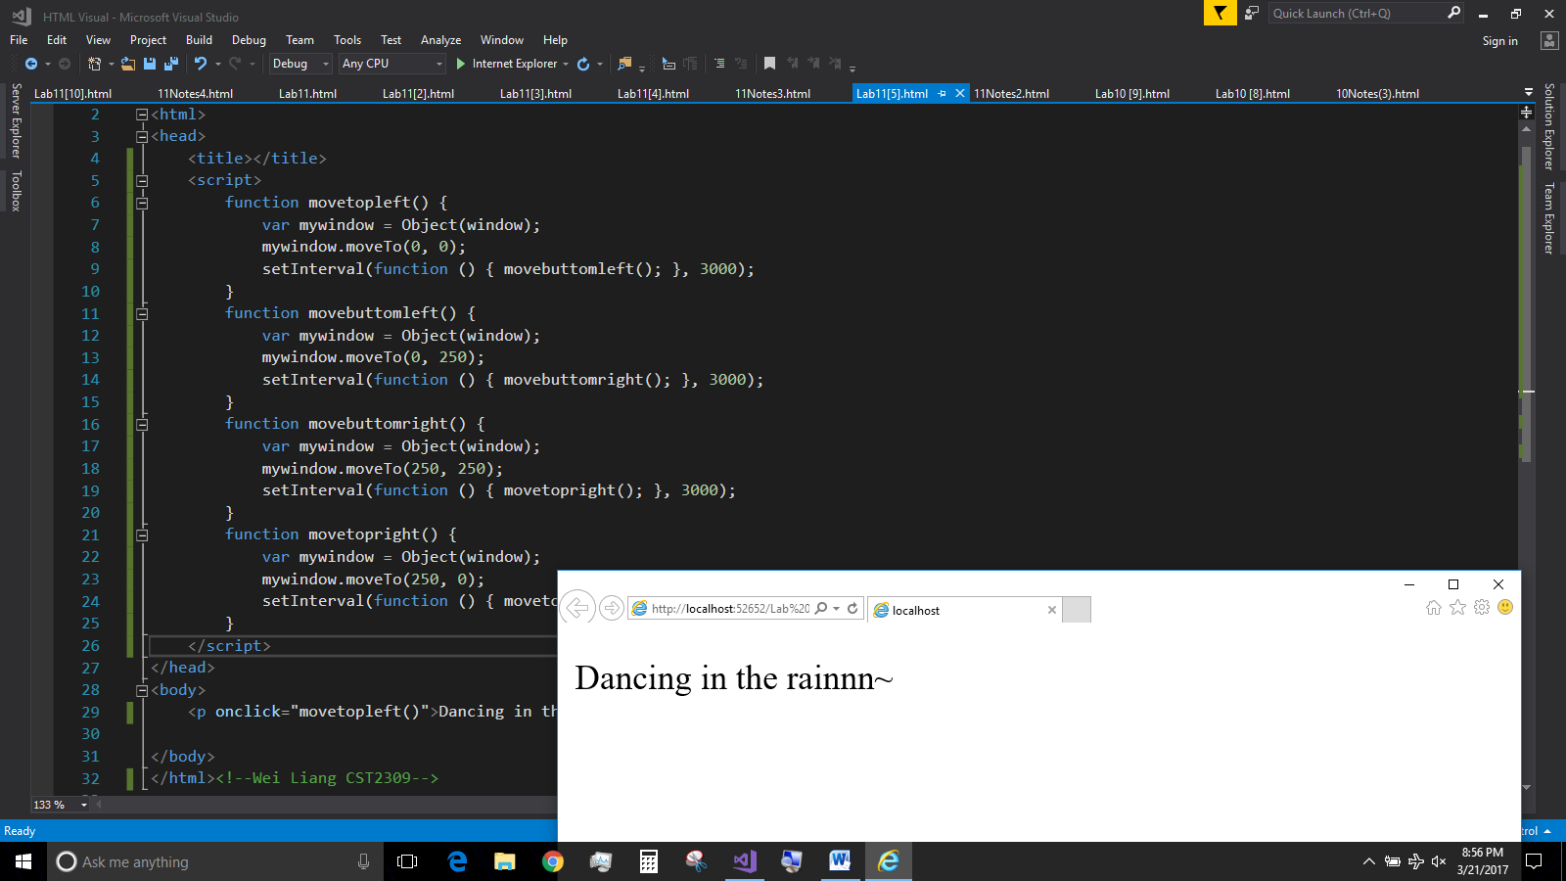

**(Question 5 Code only applies and work on internet explorer) ☹**